**Lab 07 Geocoding using Naver map API**

학습목표

-

-

-

**1. Data Collect**

Download ‘서울시 병의원 위치 정보’ in ‘서울열린데이터 광장’It must be downloaded in CSV file format)

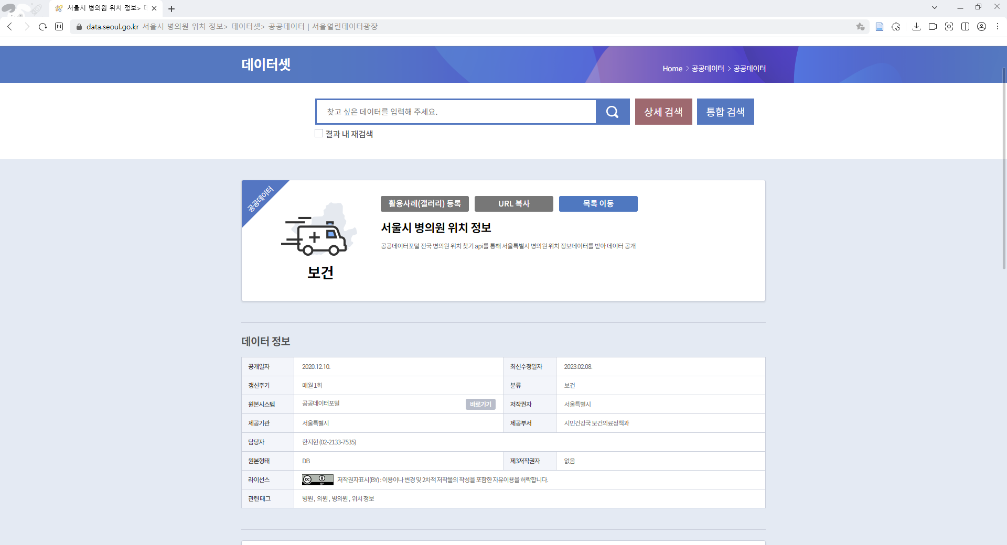

The downloaded file is as follows.

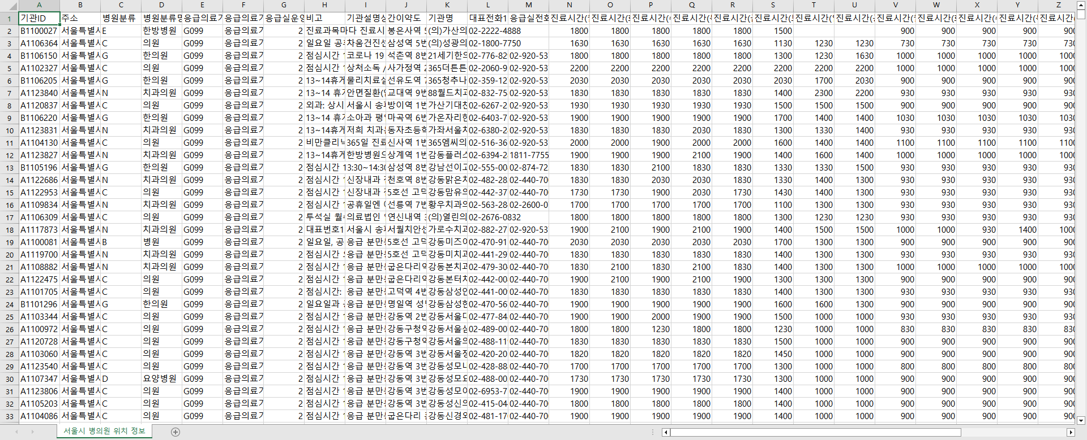

Since we only need address data, we delete unnecessary data as follows.

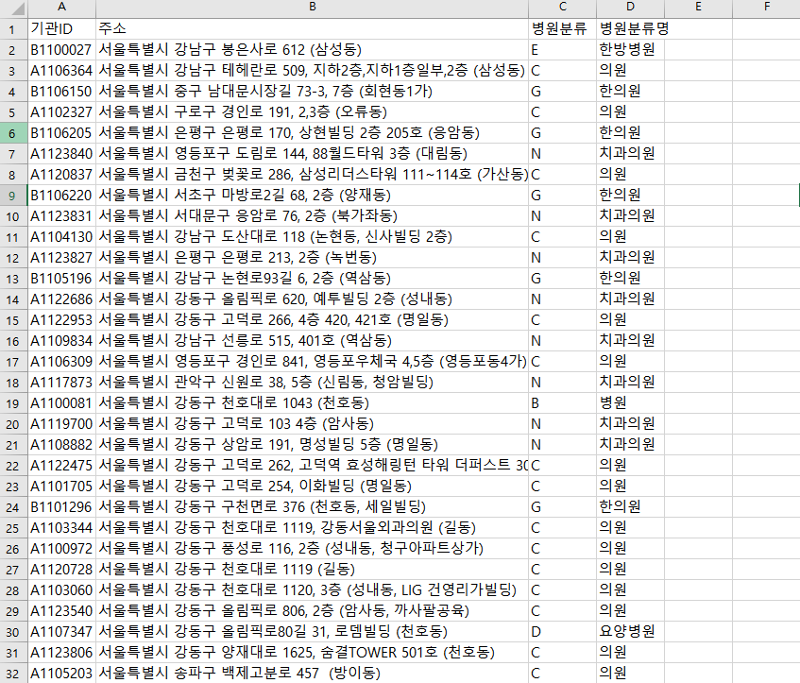

After classifying hospitals through filters, prepare a new document.

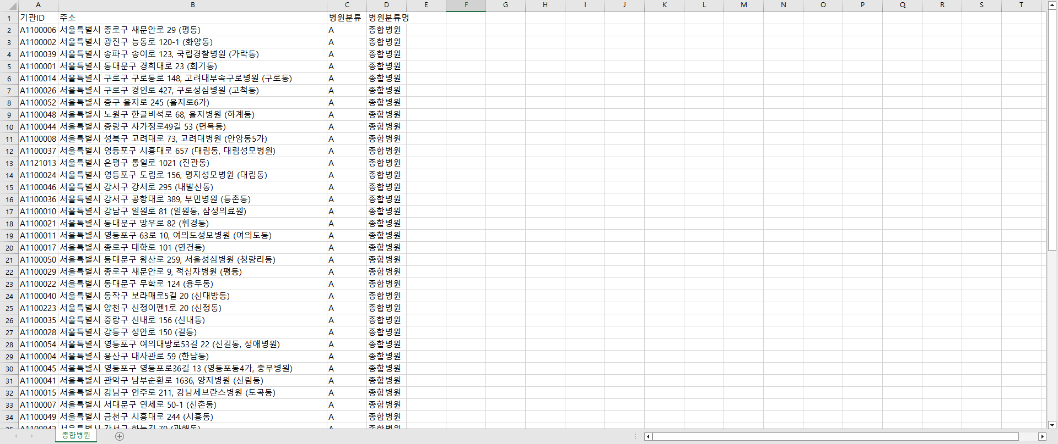

**2. Naver map API**

To use the Naver Map API, you must join the Naver Cloud platform.

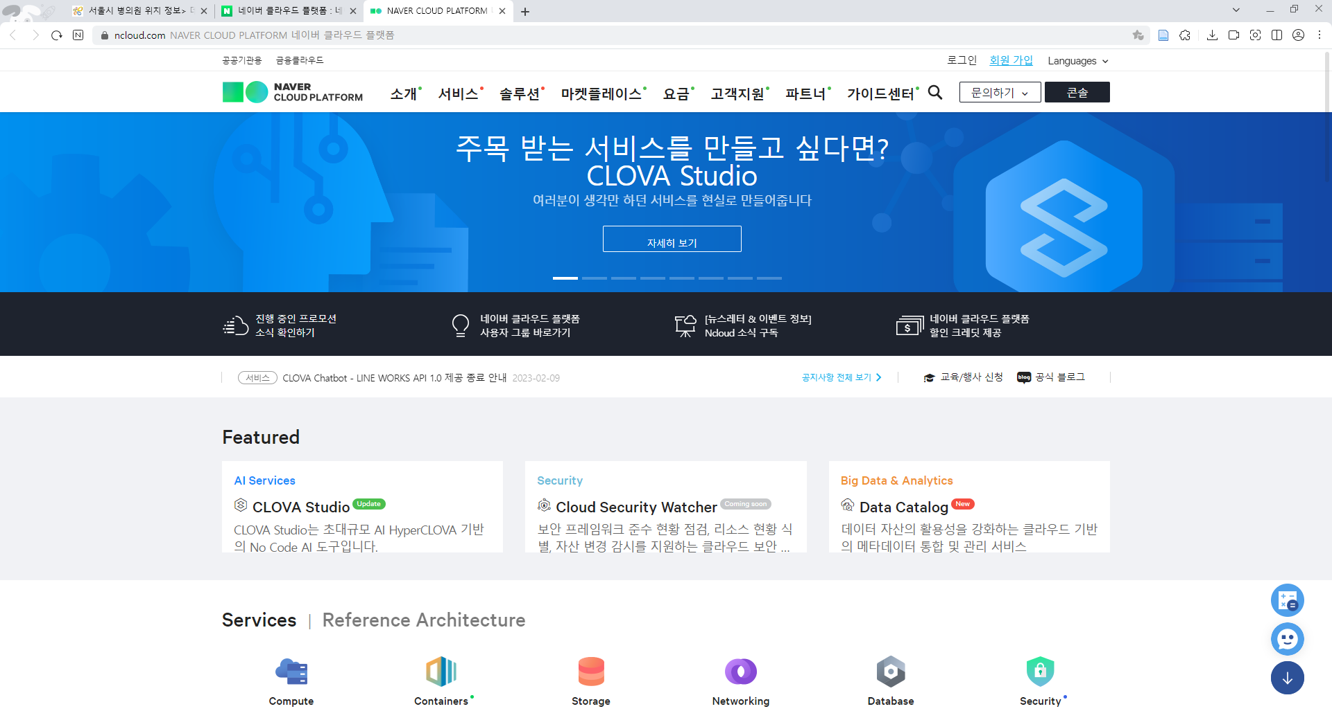

After signing up for the cloud platform, apply to use Maps. There is no cost because you can use up to a certain amount for free.

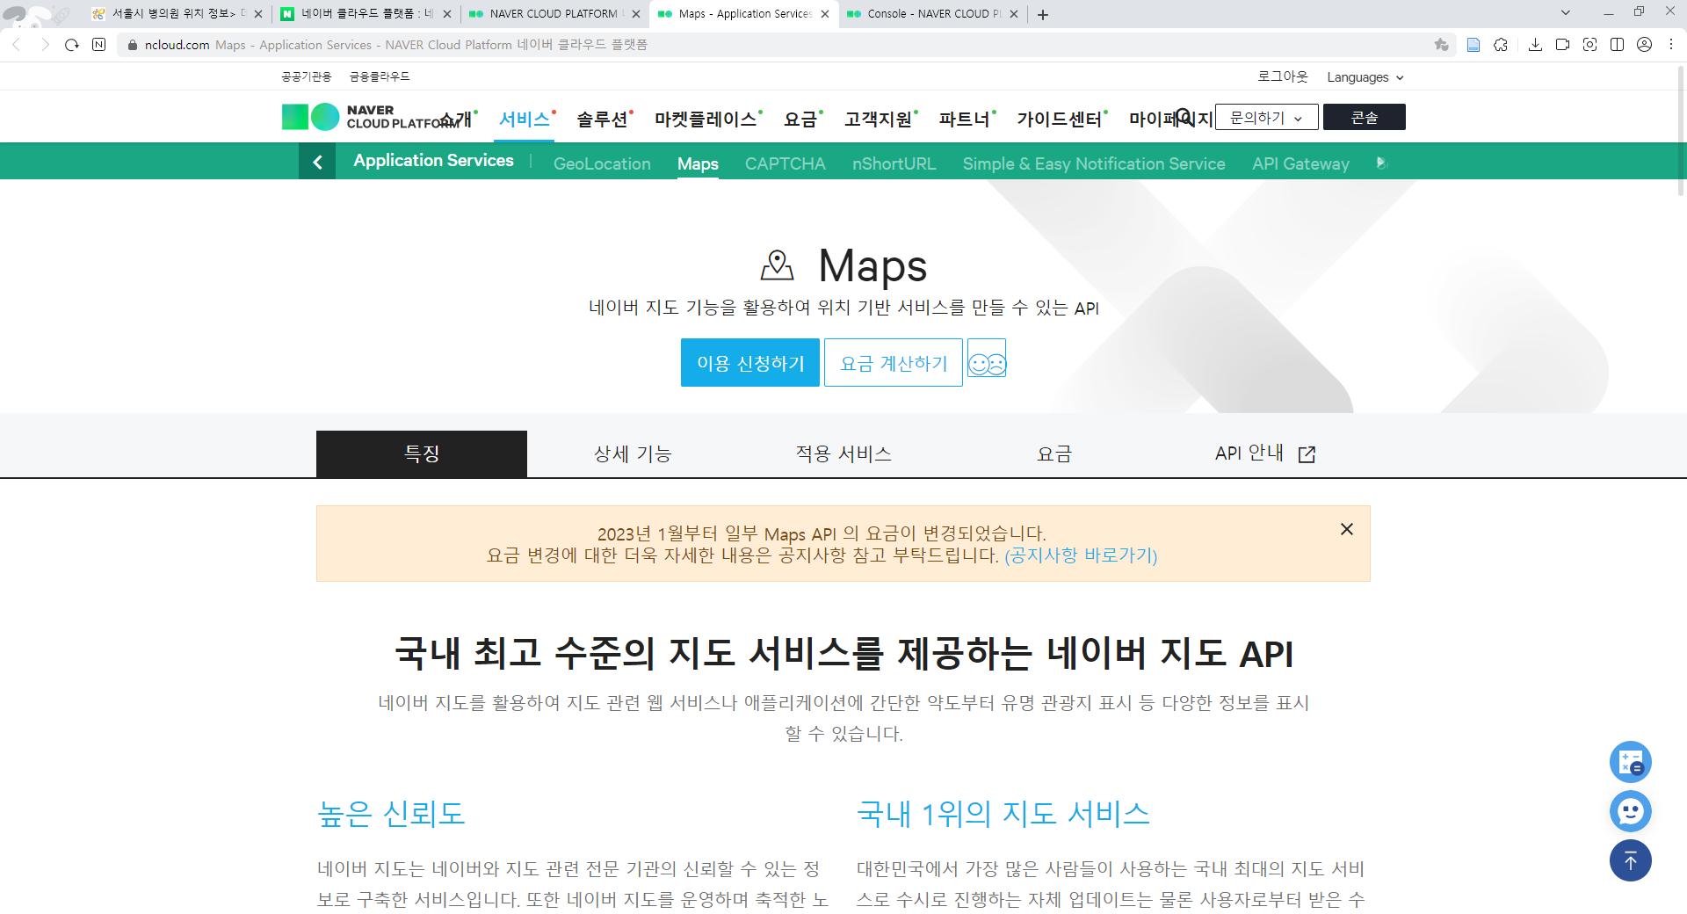

After applying for use, click Register Application and register as follows.

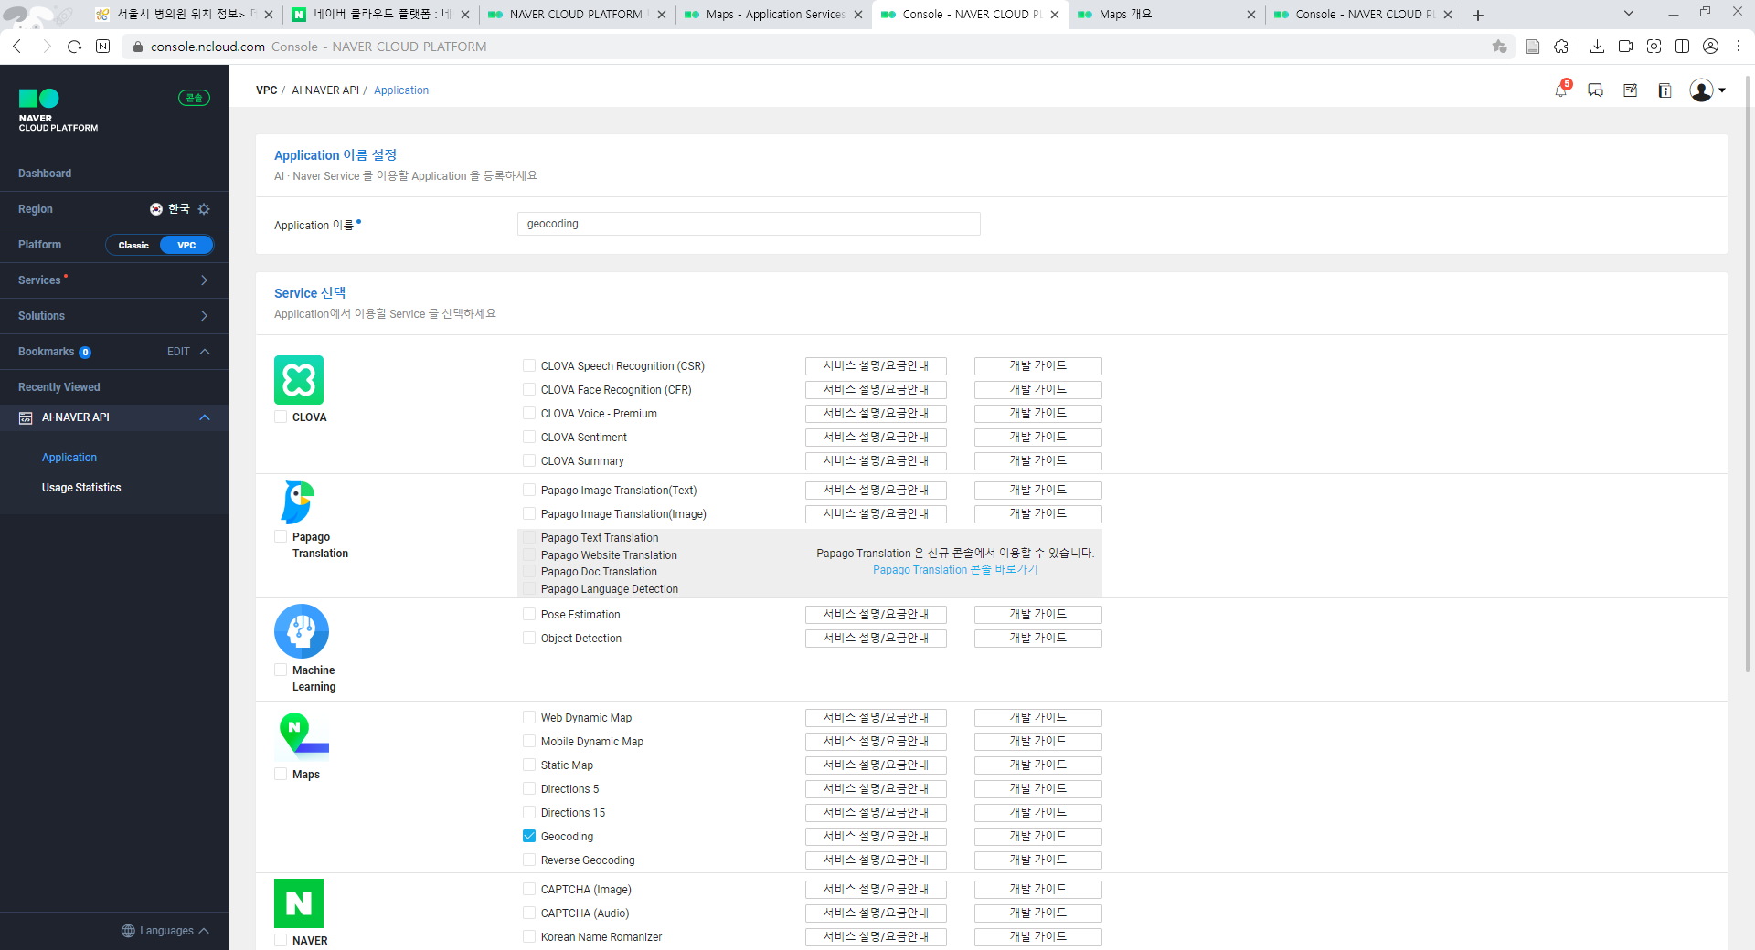

When the application registration is completed, a client key and a client secret are issued. These two are copied because they are used for geocoding.

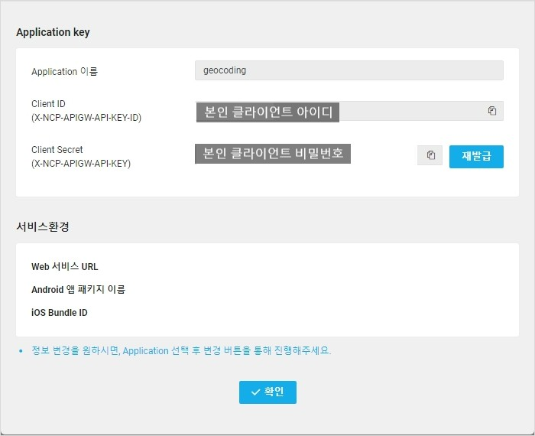

**3. Geocoding**

First, run the drive mount as follows:

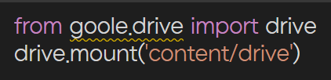

And then import as below:

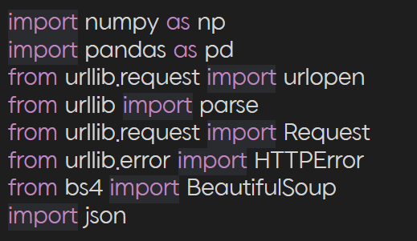

urllib is a package of multiple modules for URL operations. Beautiful Soup is a Python library for pulling data out of HTML and XML files.

The full code to be used in this exercise is shown in the figure below.

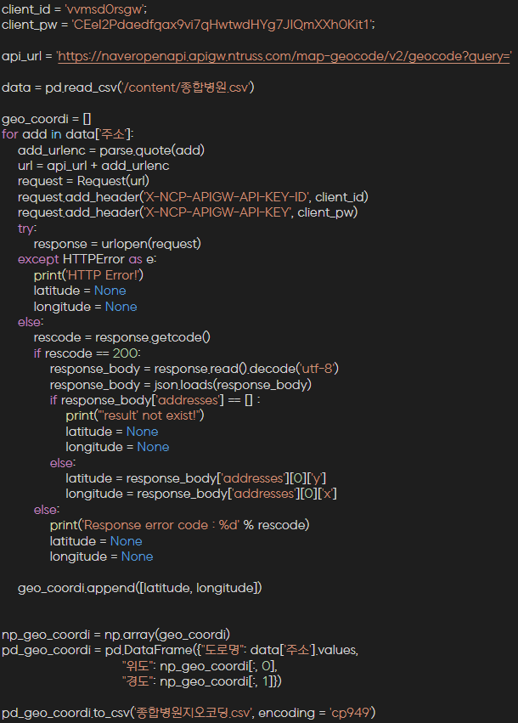

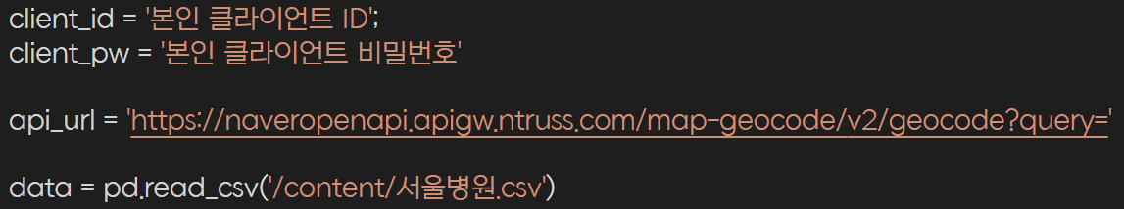

The three lines of code above are codes that enter your Naver Cloud platform ID and password Naver Map API address to import Naver Map API. The data=pd.read_csv(") in the last line is the code for loading CSV files using pandas.



The above code is a code for storing geocoded data as a CSV file. The reason for running "encoding = 'cp949'" is to convert the CSV file set to UTF-8 into a Korean encoding called cp949 because the following error may occur if the CSV file is downloaded without conversion.

**Assignment**

1. After performing geocoding for each subject, submit the .ipynb file and .csv.

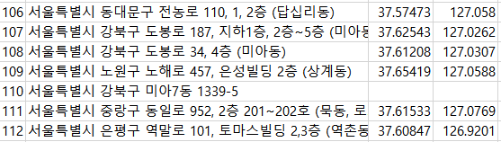

2. The table above shows the results of executing geocoding. Write by inferring the reason why only the address of 110 failed geocoding.